**Project Design Phase**

**Solution Architecture**

|  |  |
| --- | --- |
| Date | 13 April 2025 |
| Team ID | SWTID1743517551 |
| Project Name | HouseRent |
| Maximum Marks | 4 Marks |

**Solution Architecture:**

Solution architecture is a comprehensive framework that bridges the gap between the business requirements and the technological implementation of a solution.

**Objectives of Solution Architecture:**

* Identify and implement the best-fit **technology stack** to solve specific business challenges (e.g., housing rental, landlord-tenant interaction).
* Describe the **system structure, data flow**, behavior, and interaction between different modules and services.
* Define **key features**, **phases of development**, and **technical requirements**.
* Provide a scalable and modular architecture that ensures maintainability and performance.

**Tech Stack Used**

|  |  |  |
| --- | --- | --- |
| **Layer** |  | **Technology Used** |
| Frontend |  | React.js (with Axios, React Router) |
| Backend |  | Node.js + Express.js |
| Database |  | MongoDB (NoSQL) |
| Authentication |  | JWT (JSON Web Token) |
| Deployment |  | (Optional: Netlify/Vercel & Render) |
| Tools |  | Postman, VS Code, GitHub |

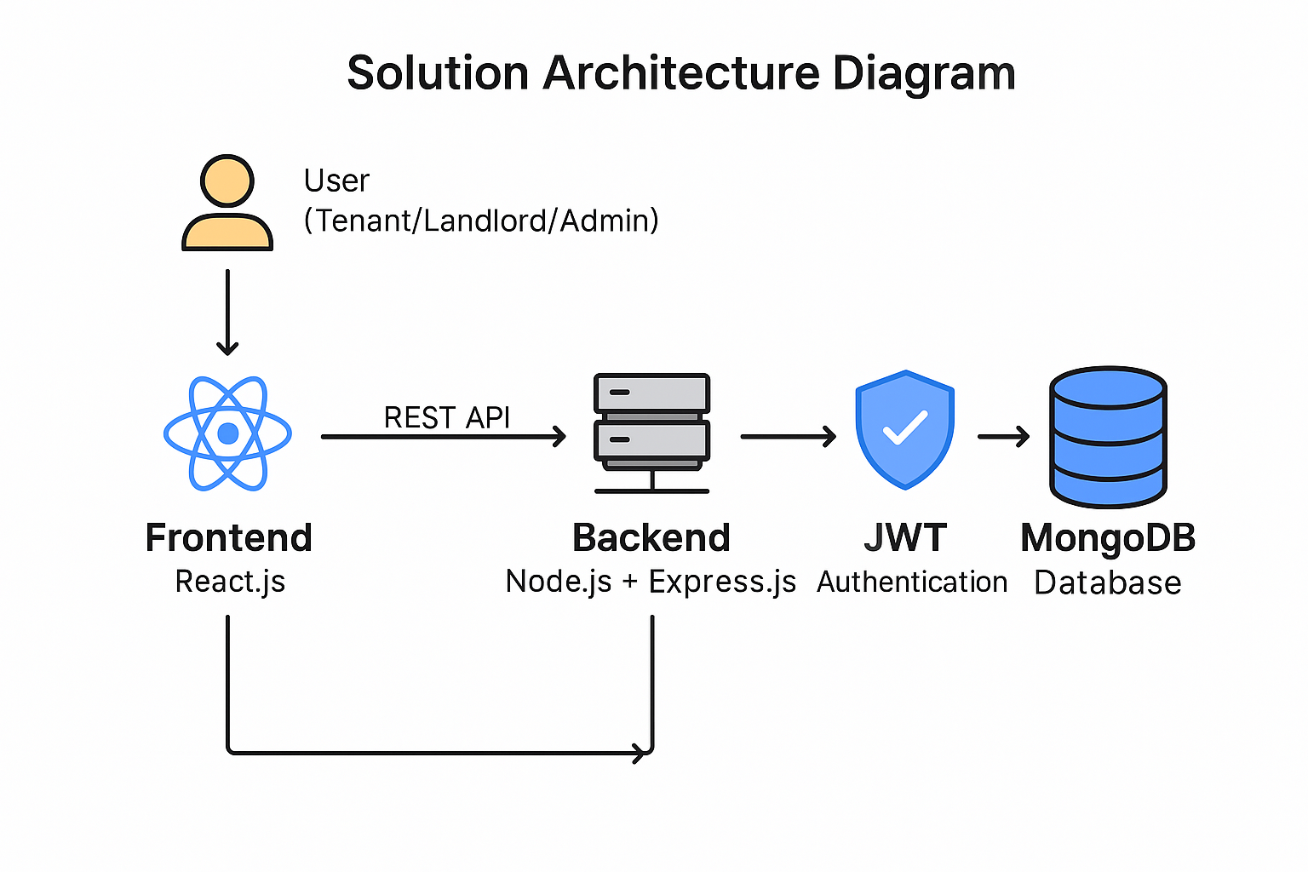

*Figure 1: Architecture and data flow of the house rent web application*